Supporting Information

Trophic Flexibility and the Persistence of Understory Birds in Intensively Logged Rainforest
DAVID P. EDWARDS,^{1,2*} PAUL WOODCOCK,¹ ROB J. NEWTON,³ FELICITY A. EDWARDS,¹ DAVID J. R. ANDREWS,¹ TEEGAN D. S. DOCHERTY,¹ SIMON L. MITCHELL,¹ TAKAHIRO OTA,¹ SUZAN BENEDICK,⁴ SIMON H. BOTTRELL,³ AND KEITH C. HAMER¹

¹Institute of Integrative and Comparative Biology, Faculty of Biological Sciences, University of Leeds, Leeds, LS2 9JT, UK. ²School of Tropical and Marine Biology, James Cook University, Cairns, Queensland 4878, Australia. ³Earth Surface Sciences Institute, School of Earth and Environment, University of Leeds, Leeds, LS2 9JT, UK. ⁴School of Sustainable Agriculture, Universiti Malaysia Sabah, Malaysia
*email dave.edwards@jcu.edu.au

This Electronic supplementary material includes:

Appendix S1. Map of sample locations.

Appendix S2. Methods for stable isotope analysis.

Appendix S3. Table of feeding guilds, trophic positions and abundances of recorded species.

Appendix S4. Proportional change in trophic position following logging against trophic position in primary forest.

Appendix S5. Mean trophic position of shared species grouped within feeding guilds.

Appendix S6. Discussion of trophic positions within primary forest

Appendix S1. Map of sampling locations. Blue diamonds represent primary forest transects. Red circles represent degraded forest sites, each consisting of two transects. Dark grey=unlogged forest, mid-grey=once-logged forest, pale grey=twice-logged (degraded) forest, white=oil palm.
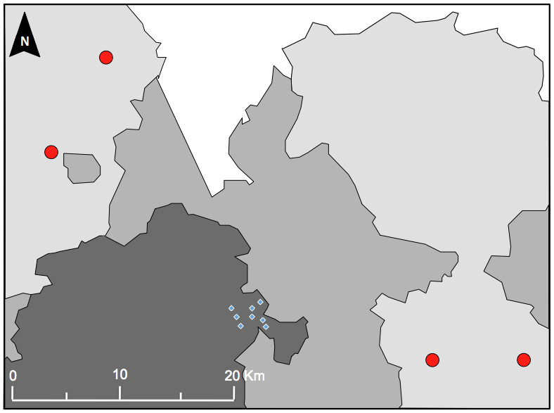

Appendix S2. Methods for stable isotope analysis.
Samples sealed in tin capsules were loaded into the autosampler and purged with helium for 20 minutes at 200 ml per minute before analysis began. During a single run, a sample was dropped into a combustion tube in a furnace set at 1015 °C under a flow of helium. This was timed so that the sample arrived at the hottest part of the furnace to coincide with a pulse of pure oxygen introduced into the helium stream. The amount of oxygen used was increased substantially for the larger plant samples. The gases resulting from the sample combustion were passed through chromous oxide and silvered cobaltous/cobaltic reagents to ensure that all carbon and nitrogen in each sample was quantitatively converted to CO₂ and N₂ respectively, before passing through a second furnace at 650°C containing copper wires to remove excess oxygen. A magnesium perchlorate and carbosorb trap was used to remove water and CO₂ from the gas stream, before the gas passed through a chromatographic column (standard CHN column run at 85°C [Elemental Analysis, No: E3000], or high resolution CN column at 125°C [Elemental Analysis, No: E11528], or HNO column at 125°C [Elemental Analysis, No: E3001]) to separate N₂ for isotopic analysis. No systematic differences were observed when using different chromatographic columns.
The atomic masses 28 (=¹⁴N₂ isotopomer) and 29 (=¹⁵N-¹⁴N isotopomer) were monitored continuously throughout each run and the δ¹⁵N value of each sample was calculated relative to a pulse of bottled N₂ introduced before the arrival of the sample peak: δ¹⁵N (‰) = ([R_{sample}/R_{standard}]-1) x 10³, where R_{sample} is the sample ¹⁵N:¹⁴N ratio and R_{standard} is the ¹⁵N:¹⁴N ratio for N₂. Ammonium sulphate standards USGS-25 and USGS-26 interspersed every 8-12 samples were used to correct these values to the international δ¹⁵N_{air} scale (USGS-25=-30.4; USGS-26=+53.7‰). Repeats of a yeast standard from a single column produced standard deviations of 0.1 to 0.3 ‰, with an average across all columns (265 analyses) producing a value of –0.55 ± 0.28 ‰ (1SD).
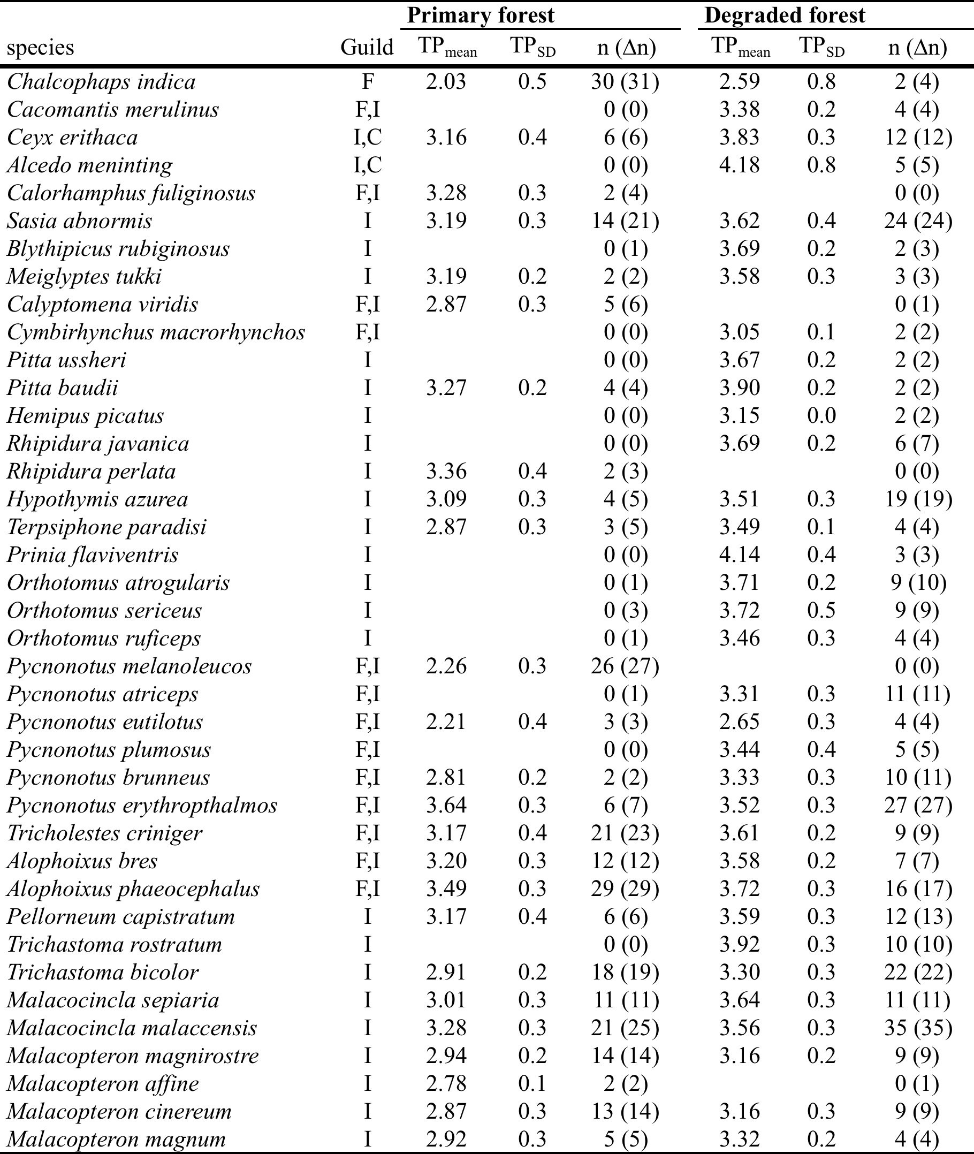
Appendix S3. Feeding guilds, trophic positions and abundances of recorded species. Feeding guilds: F, frugivore; N, nectarivore; I, insectivore (including snails, spiders and other arthropods); C, carnivore (small fish and amphibians); O, omnivore (three or more of the above). TP, trophic position; n, number of isotope samples (∆n, overall abundance). Only species with ≥2 individuals in a forest type have estimates of trophic position.
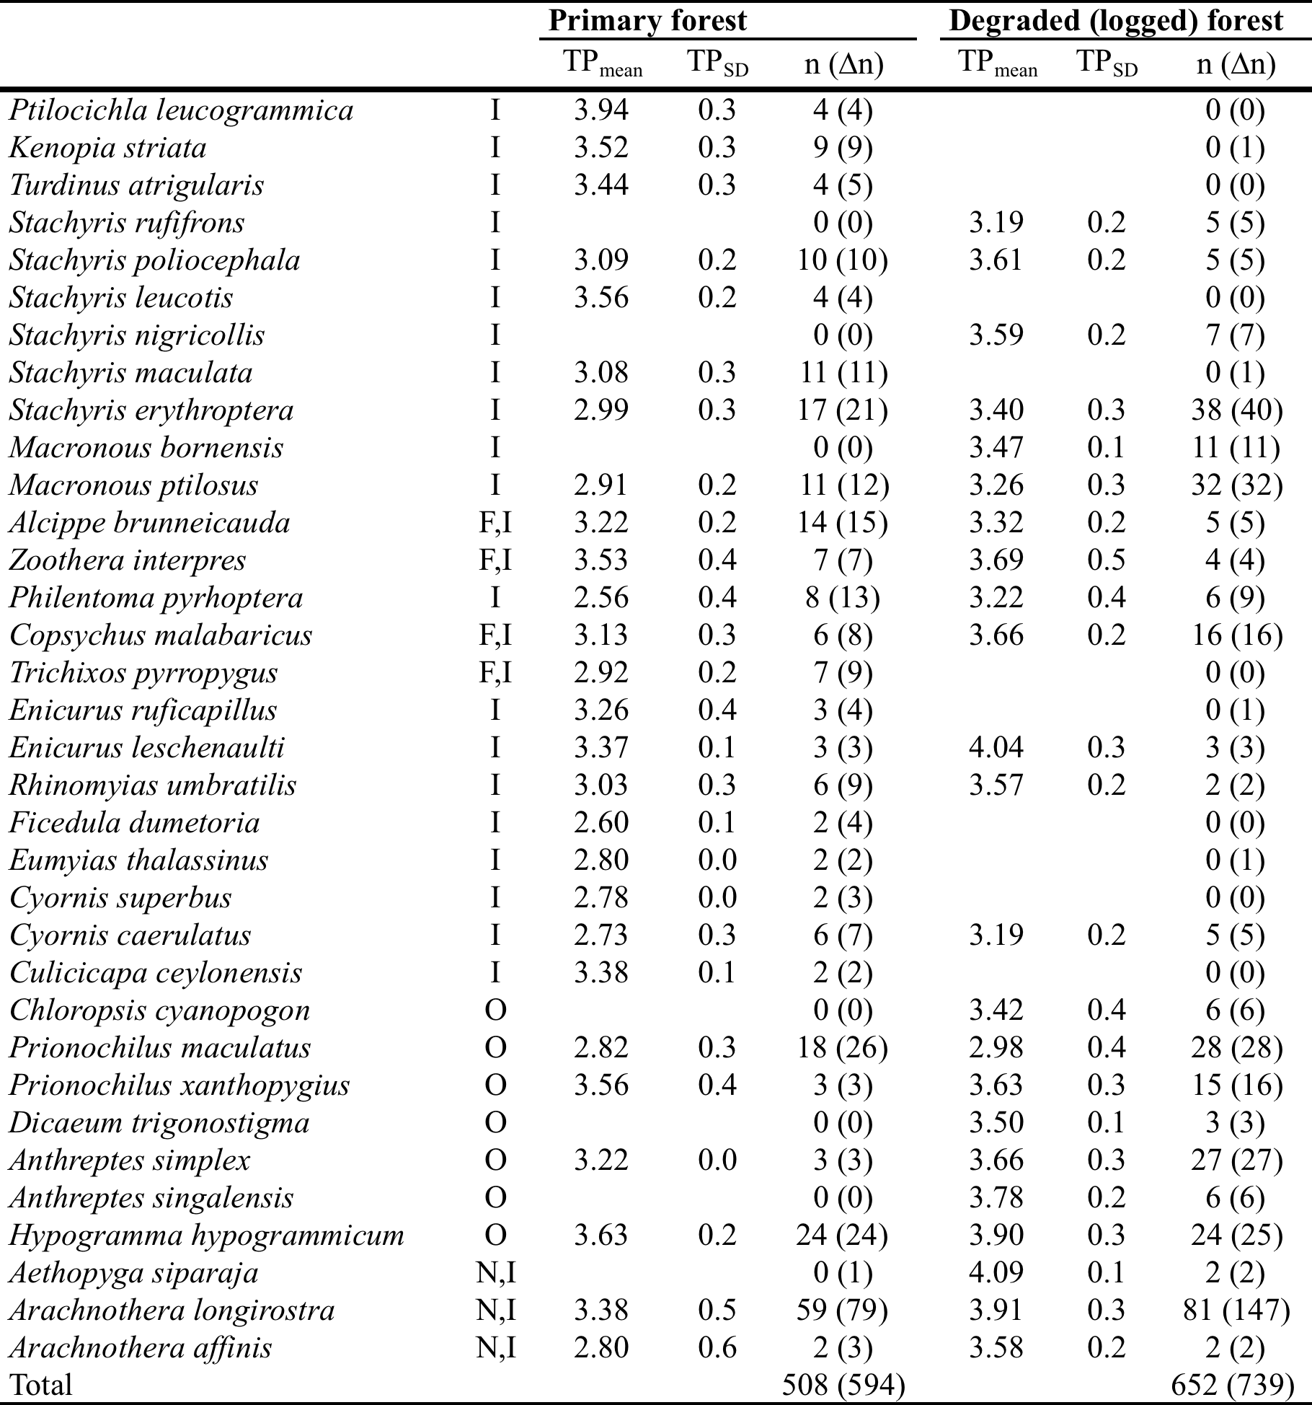
Appendix S4. Proportional change in trophic position following logging against trophic position in primary forest.

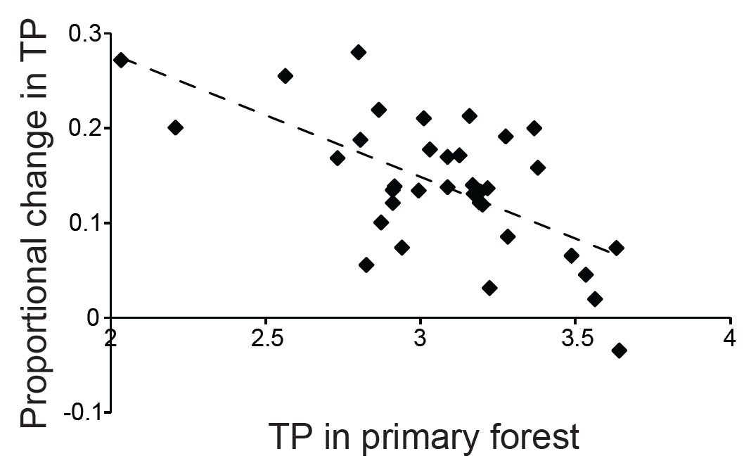

Appendix S4. The proportional change in a species’ mean trophic position following rainforest degradation ((MTP_{degraded} – MTP_{primary})/MTP_{primary}) against the species’ mean trophic position in primary forest (GLM: F_{1,24}=30.7, P<0.0001).

Appendix S5. Mean trophic position (SD) of shared species within feeding guilds in primary and degraded forest. Statistics are outputs from LMEs. Feeding guilds: F, frugivore; I, insectivore (including snails, spiders and other arthropods); C, carnivore (small fish and amphibians); N, nectarivore; O, omnivore (three or more of the above). TP, trophic position.
 | Primary forest |  | Degraded forest
Guild | TP_{mean} | TP_{SD} | TP_{mean} | TP_{SD} | df | F | p
F | 2.03 | 0.5 | 2.59 | 0.8 | 1,30 | 1.9 | 0.18
F,I | 3.28 | 0.4 | 3.53 | 0.3 | 1,188 | 33.5 | <0.0001
I | 3.01 | 0.3 | 3.44 | 0.3 | 1,401 | 200.6 | <0.0001
I,C | 3.16 | 0.4 | 3.83 | 0.3 | 1,16 | 18.7 | 0.0005
N,I | 3.36 | 0.5 | 3.90 | 0.3 | 1,141 | 70.1 | <0.0001
O | 3.29 | 0.5 | 3.51 | 0.5 | 1,137 | 16.3 | 0.0001

Appendix S6. Discussion of trophic positions within primary forest
Our bird community in primary forest spanned a wide range of mean trophic positions up to 3.9 (Bornean Ground-babbler Ptilocichla leucogrammica; probably feeding mainly on predatory arthropods in leaf-litter). Only three species (6%) occupied low trophic positions (< 2.5) and two of these (Emerald Dove Chalcophaps indica = 2.0; Black-and-white Bulbul Pycnonotus melanoleucos = 2.3) were previously considered to feed mainly on fruit (Lambert 1992; Myers 2009). A further 43 species (80%) had trophic positions between 2.5 and 3.5, indicating either a diet of mainly herbivorous invertebrates (e.g. among the Picidae [woodpeckers], Rhipiduridae [fantails], Muscicapidae [flycatchers and forktails] and Timaliidae [babblers], which are mainly insectivorous; Appendix B) or a mixed diet combining nectar and/or fruit with herbivorous and carnivorous invertebrates (e.g. Little Spiderhunter Arachnothera longirostra [TP = 3.4], which feeds on nectar and small invertebrates, frequently including spiders; Myers 2009). Seven species (13%) had trophic positions over 3.5, indicating a diet comprising mainly carnivorous prey, and these included two species of babbler along with Purple-naped Sunbird Hypogramma hypogrammicum, which are omnivorous but are reminiscent of small babblers in their foraging behaviour and feed mainly on arthropods, including spiders (Wong 1986; Lambert 1991; Myers 2009). The small proportion of species that we recorded specializing on fruit or nectar differs from tropical forests in other regions (e.g. Karr 1980) and probably reflects a comparatively low abundance of fruits and flowers within the understory of dipterocarp forests of Southeast Asia (Wong 1986).

Literature Cited
Karr, J. R. 1980. Geographical variation in the avifaunas of tropical forest undergrowth. Auk 97:283-298.
Lambert, F. R. 1992. The consequences of selective logging for Bornean lowland forest birds. Philosophical Transactions of the Royal Society of London Series B 335:443-457.
Myers, S. 2009. Birds of Borneo: Brunei, Sabah, Sarawak, and Kalimantan. Princeton University Press, USA
Wong, M. 1986. Trophic Organization of Understory Birds in a Malaysian Dipterocarp Forest. Auk 103:100-116.

